**🤝 New Location in the LMU Klinikum Großhadern**

We’re excited to share that SmartFoodiehas officially opened itsnew **e-Bistro24H** at **Besucherstraße, 1st Floor, Klinikum Großhadern in Munich**! Located inside one of Munich’s most renowned hospitals, our newest launch brings **fresh, warm, healthy and delicious food options** to healthcare professionals, patients and visitors — filling the gap in a place where dining choices have long been limited. Whether you’re looking for a quick bite, a nutritious meal on the go or a late-night option, SmartFoodie’s e-Bistro24H is now just steps away — and **available 24/7** to serve you anytime.

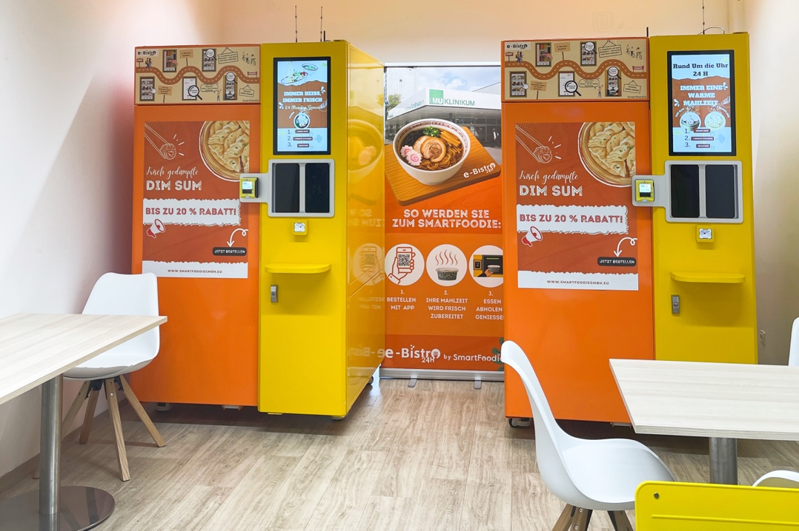

**🎉 Successful Free-Tasting Event**

To celebrate our new opening at Klinikum Großhadern, we hosted a special Free-Tasting Event last Friday (09.05) – and it was a big success! Throughout the event, guests had the chance to sample a delicious variety of SmartFoodie favorites. In total, **250 portions** were served – including over 1000 of our tasty dumplings, as well as several dozen servings of udon noodles, fried rice and other specialties. The event also featured a **prize wheel** with exclusive coupons and gifts, plus our fun **6-second timer challenge** – where two lucky participants actually won a **free dish** by beating the clock!

一群人在商店里

AI 生成的内容可能不正确。

The atmosphere was amazing — full of laughter, conversations and **great satisfaction**. Thank you to everyone who stopped by, tasted our food and shared your valuable feedback. We loved meeting you all! **❤️**

**🌟** We’re proud to extend our services to the Klinikum Großhadern community. Whether you're in a rush, working late, or just struggling to find something satisfying to eat, SmartFoodie is here to serve you with **delicious, nourishing meals — Always hot, always yours, 24/7 nonstop!**

📍 Visit us now at **Klinikum Großhadern (Besucherstraße, 1st Floor)**  
🕘 Opening Hours: **24/7**

👉 Follow us on Instagram [**@smartfoodie_gmbh**](https://www.instagram.com/smartfoodie_gmbh) for the latest updates📲

👉 [**Download**](https://qrco.de/bfPKef) the SmartFoodie app and enjoy 20% off your order until 08.06!